ASSIGNMENT-2(Report and Outcomes)
MACHINE LEARNING(CS-697AB)

Pakalapati Sri Lakshmi Prasanna Kumar
myWSUID: W845T858

Report:

In This Assignment, we used 4 libraries for detection System. As follows:

- Train Live
- Train Spoof
- Test Live
- Test Spoof

Here, Live: It is original fingerprint given by a person.

Test: It is obtained from an image of the fingerprint.

Steps:

1.Import Images from files, later read one by one. And resize the images as well.
2.After resizing the images, stored into an array. After that covert the array 2D into 1D by using ravel function. Now, the data is stored in a single data-frame set i.e., test_img.
3. By using the function for all rows add a new column called label and assign value as zero. And similarly do for test live data also in this way assign value as one for all rows and add label.
4.Presentnow follow the above steps for train data also and create data frames for train_img.
5.Divide the data into Y_train, X_train, Y_test, X_test to the SVM model.
6.Training the SVM model with parameters c=1, degree=1, kernel=`linear` and fitting models.
7. After all this, predict the X_test and comparing the outcome values with Y_test gave the accuracy score and confusion matrix. The Outcome of model gave an accuracy is 85.25%.

Code and respective outcomes:
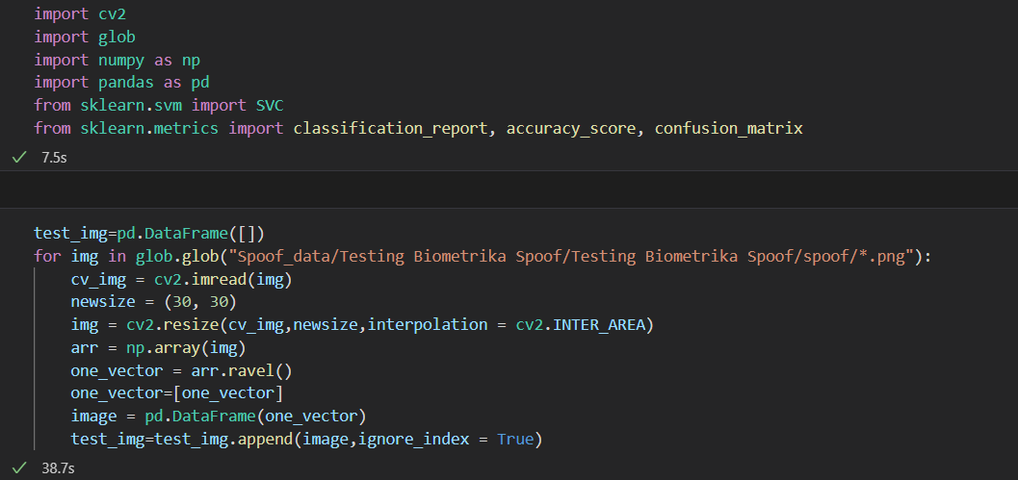
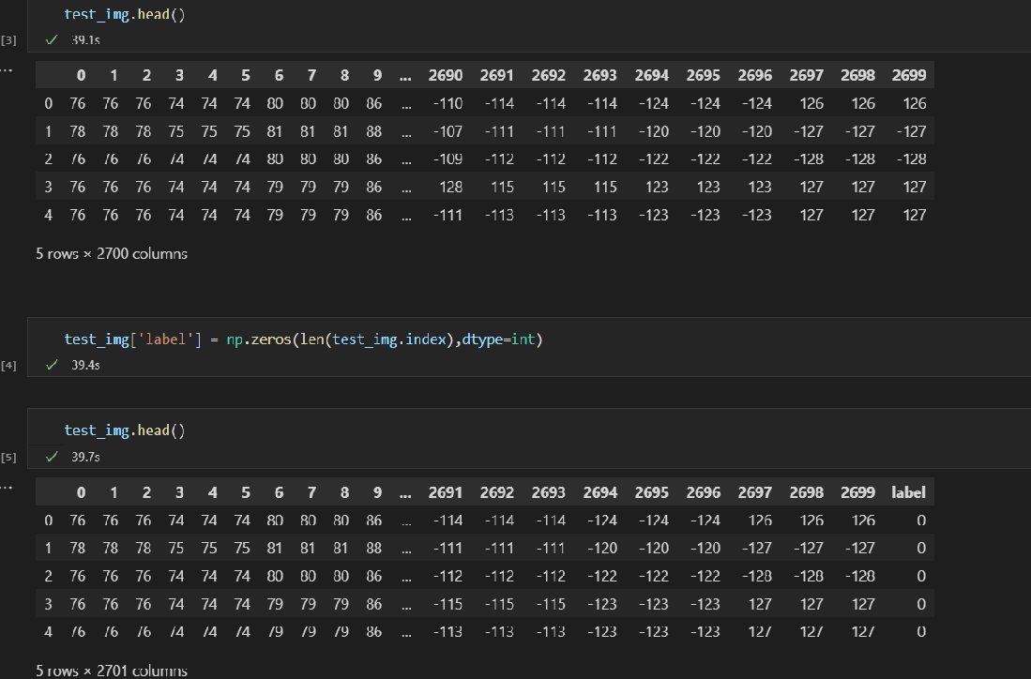

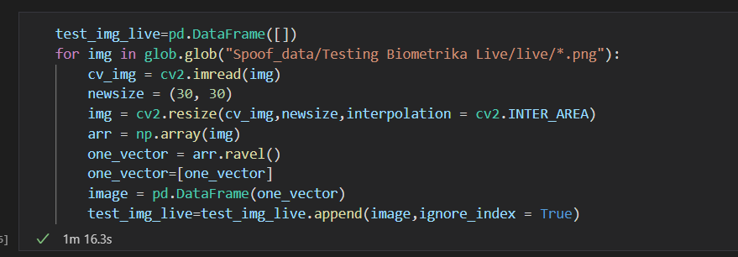

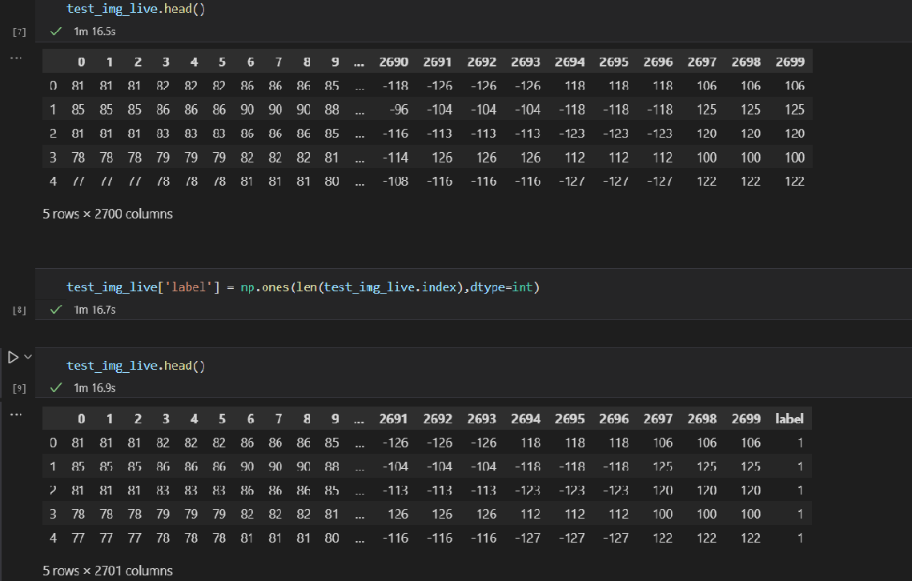

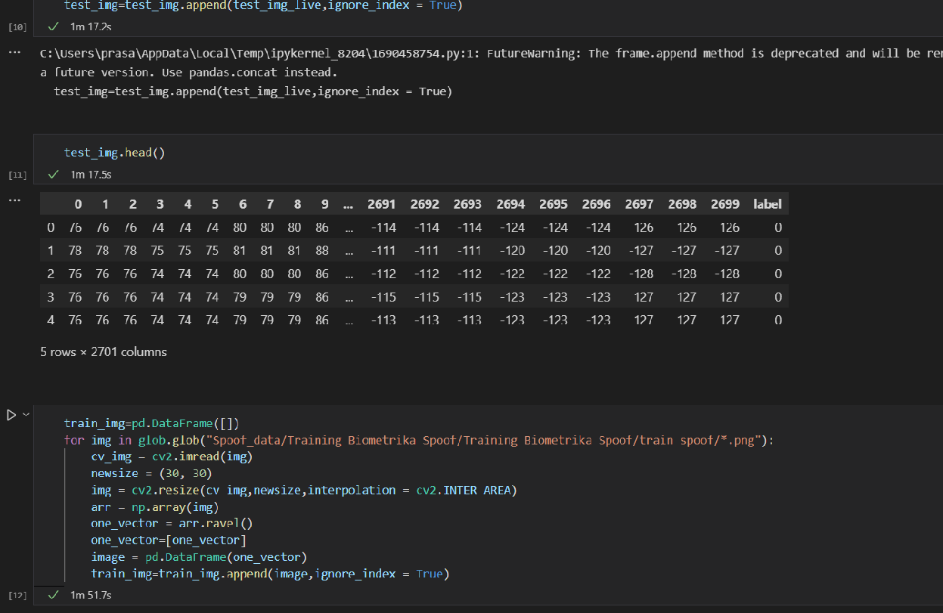

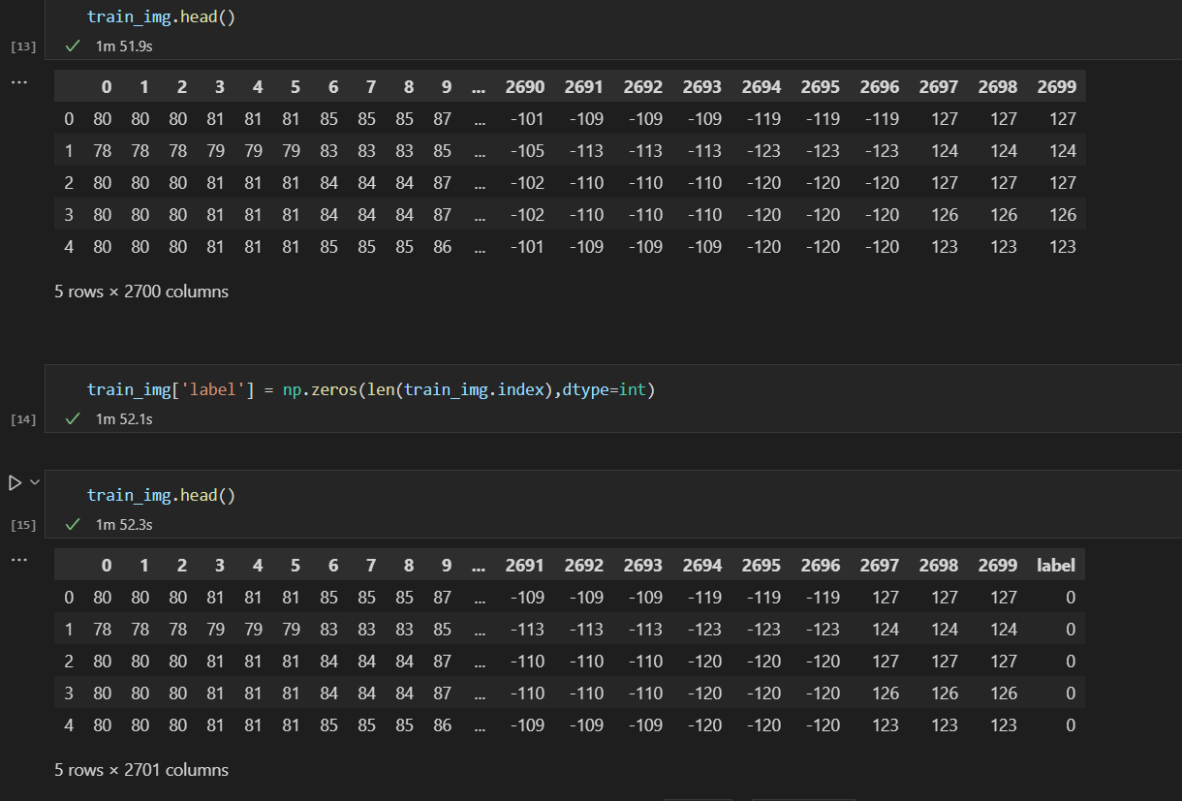

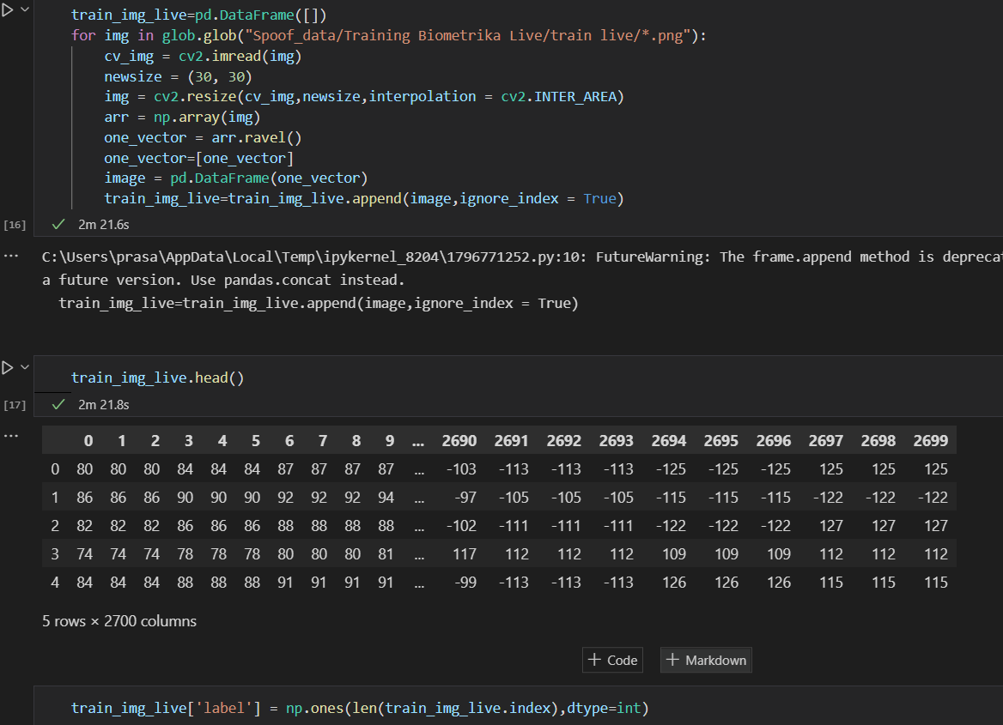

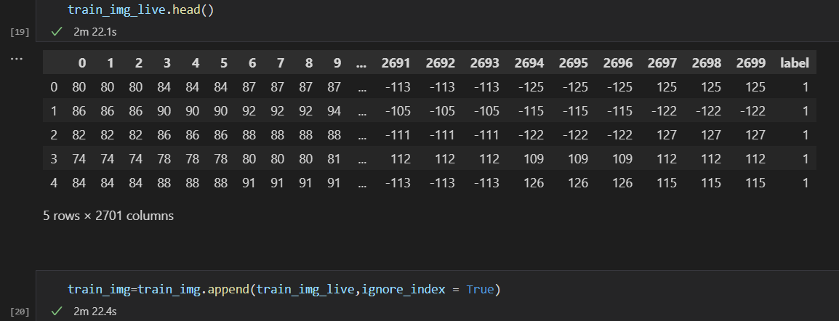

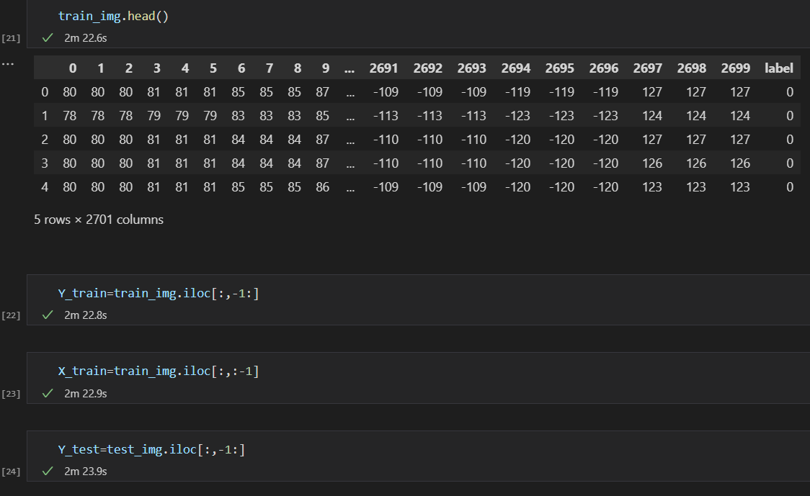
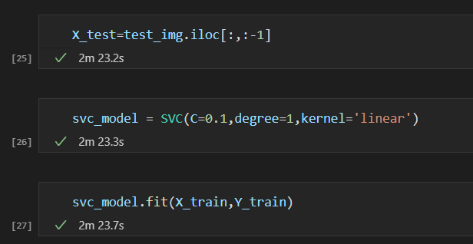
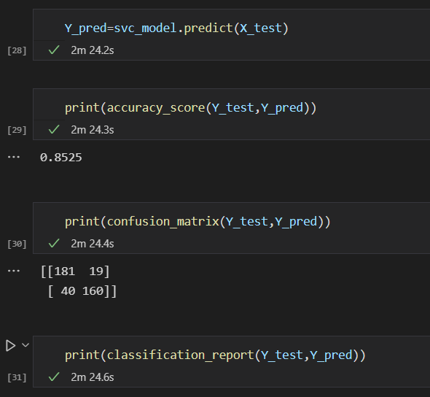

Result: